**Lessons Learned Report**

When comparing the groups of clients that defaulted vs non-defaulted, there were not any differences in most of the demographic groups. I did however note that the credit limits, on average, were higher in the groups that did not default. Overall mean of defaulter is $129,483 and non-defaulters is $176,523 for a difference of a little over $47,000.

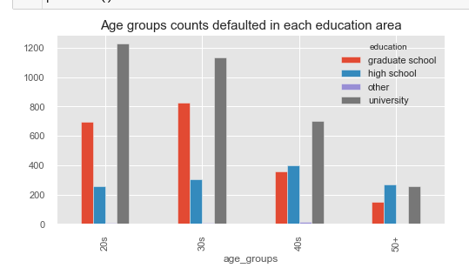I looked a little closer into the group of clients who did default the next month. The data showed that the groups that had the most defaulters were the clients in their 20’s with a university education and those in their 20’s and 30’s with a graduate education.

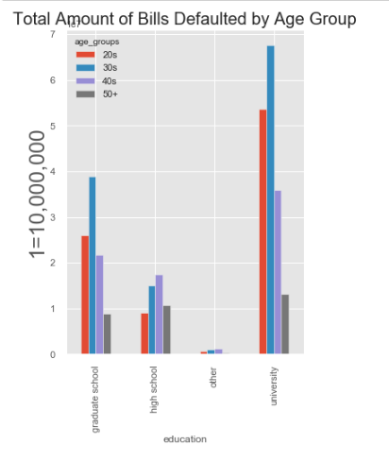

However, when I looked at the total dollar amount of debt from these demographics, the 20’s and 30’s with a university degree were quite a bit higher than the 3rd total dollar amount which is the 30’s with a graduate school degree.

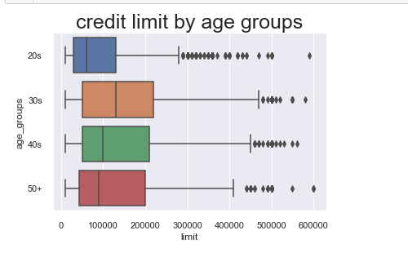Some interesting things to note. Women in their 20’s and 30’s had higher on average higher credit limits than their male counterparts. There were also more women who defaulted in their 20’s and 30’s than men? Does this have to do with the higher credit limit being offered to the women?

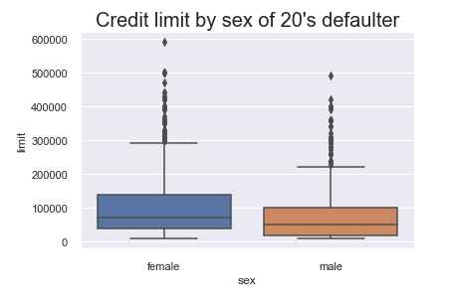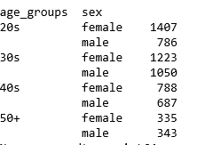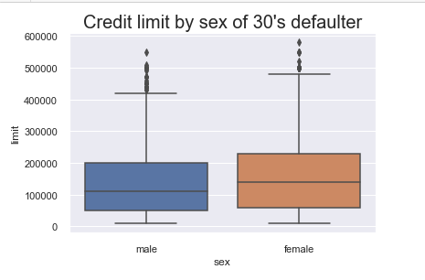Also, the 30’s had the largest number of defaulters overall and this group has the highest credit limit. Does this group have too much credit?